Talk about these instruments as a ‘survey’/overview of what’s already on the market

Then talk about the instruments that Dr. James uses for TEES – Panetti, Karl Storz set

Daniele used the ultrasonic bone cutting (demonstration at the TEES course in October)

David Pothier uses the standard Karl Storz ear surgery kit (no suction)

Good overview of currently existing tools for TEES: “ Ins t rumen ta tion and Technologies in Endoscopic Ear Surgery”(1)





hair trimmer

Good bone removal:

Stryker parasonic aspirator – has irrigation and aspiration but very expensive -> initial cost 100 000 + 600 disposable tips

Neuro-endoscopy instruments from Karl Storz Catalogue: *Cerebral Endoscopy for Neurocysticercosis –* Jaime G. Torres Corzo, M.D.

* Instruments are fed through a trocar, which also feeds the endoscope and the trocar is held in a stand – so the surgery set up is different from TEES
* However, the end effectors and sizes of these tools are useful for TEES – however TEES has its own Karl Storz catalogue and that has a full suite of internationally acceptable instruments that are used for ear surgery

Endoscopic Sinus Surgery: <http://www.medtronic.com/us-en/healthcare-professionals/therapies-procedures/ear-nose-throat/sinus-surgery.html>

Bausch and Lomb ENT Set: <http://www.bauschinstruments.com/pset/793/Functional-Sinus-Endoscopy-Instruments.aspx>

Karl Storz Endoscopic Catalogue: <https://www.karlstorz.com/ca/en/online-catalog.htm>

Sklar Sinus Endoscopy Set: <http://www.sklarcorp.com/instrument-sets/plastic-surgery/sinus-endoscopy-set.html>

Curved Suction:

Medtronic Fusion ENT Navigation System: <http://assets.medtronic.com/ent/flipbook-us/#p=44>

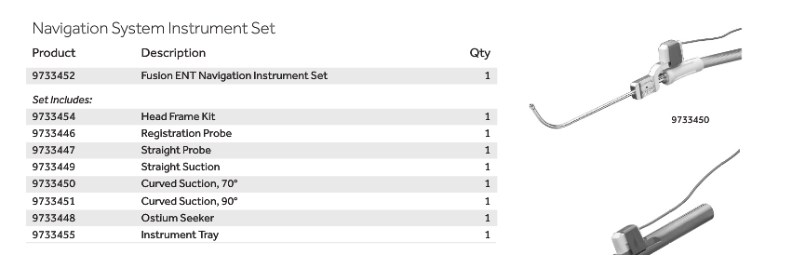

I think this has pre-curved suction (but not bendable)

<http://www.medtronic.com/us-en/healthcare-professionals/products/ear-nose-throat/image-guided-surgery/fusion-ent-navigation-system/related-navigation-products.html#supplemental>

* Frontal Suctions, 45° and 90°
* Small Straight Suction
* Suction Curettes, 45° and 90°
* Elevator
* Standard Registration Probe and Head Frame Kit (not pictured)

### ****INSTRUMENT INNOVATION****

Our ENT surgical navigation instruments feature:

* Auto-recognition and seamless verification of instruments
* HeadTracker with integrated TouchPad
* Multi-instrument tracking with up to 3 instruments at once

### ORDERING INFORMATION

[View our ENT Product Catalog](http://assets.medtronic.com/ent/flipbook-us/) or call your local ENT representative to learn more.

*Note: These surgical navigation instruments are only available as sets in the US. If you are outside the US, items in sets must be ordered individually.*

### [NUVENT EM BALLOON SINUS DILATION](http://www.medtronic.com/us-en/healthcare-professionals/products/ear-nose-throat/image-guided-surgery/fusion-ent-navigation-system/related-navigation-products.html)

### [MALLEABLE SUCTIONS](http://www.medtronic.com/us-en/healthcare-professionals/products/ear-nose-throat/image-guided-surgery/fusion-ent-navigation-system/related-navigation-products.html)

### [EM TRACKING BLADES](http://www.medtronic.com/us-en/healthcare-professionals/products/ear-nose-throat/image-guided-surgery/fusion-ent-navigation-system/related-navigation-products.html)

### [PATIENT TRACKING](http://www.medtronic.com/us-en/healthcare-professionals/products/ear-nose-throat/image-guided-surgery/fusion-ent-navigation-system/related-navigation-products.html)

### [STEALTHMERGE AND DICOM Q/R](http://www.medtronic.com/us-en/healthcare-professionals/products/ear-nose-throat/image-guided-surgery/fusion-ent-navigation-system/related-navigation-products.html)

### [STEALTHSTATION](http://www.medtronic.com/us-en/healthcare-professionals/products/ear-nose-throat/image-guided-surgery/fusion-ent-navigation-system/related-navigation-products.html)

#### RELATED LINKS

* [Overview](http://www.medtronic.com/us-en/healthcare-professionals/products/ear-nose-throat/image-guided-surgery/fusion-ent-navigation-system.html)
* [Related Powered Surgery Products](http://www.medtronic.com/us-en/healthcare-professionals/products/ear-nose-throat/image-guided-surgery/fusion-ent-navigation-system/related-powered-surgery-products.html)
* [Procedures and Techniques](http://www.medtronic.com/us-en/healthcare-professionals/products/ear-nose-throat/image-guided-surgery/fusion-ent-navigation-system/procedures-techniques.html)
* [Coverage and Reimbursement](http://www.medtronic.com/us-en/healthcare-professionals/products/ear-nose-throat/image-guided-surgery/fusion-ent-navigation-system/coverage-reimbursement.html)
* [Customer Services](http://www.medtronic.com/us-en/healthcare-professionals/products/ear-nose-throat/image-guided-surgery/fusion-ent-navigation-system/customer-services.html)

#### RELATED PROCEDURES

* [Sinus Surgery and Transnasal Skull Base Surgery](http://www.medtronic.com/us-en/healthcare-professionals/therapies-procedures/ear-nose-throat/sinus-surgery.html)
* [Otology, Neurotology, and Lateral Skull Base Surgery](http://www.medtronic.com/us-en/healthcare-professionals/therapies-procedures/ear-nose-throat/otology-neurotology-lateral-skull-base-surgery.html)
* [Cranial Surgery](http://www.medtronic.com/us-en/healthcare-professionals/therapies-procedures/neurological/cranial-surgery.html)

## ENT PRODUCT CATALOG

Medtronic offers more than 5000 products and instruments for ENT specialists.

[VIEW](http://assets.medtronic.com/ent/flipbook-us/)

## MEDTRONIC ENT

Quick access to ENT products, therapies, reimbursement, and other resources.

[MORE](http://www.medtronic.com/for-healthcare-professionals/business-unit-landing-Page/ent/index.htm)

#### CONTACT MEDTRONIC ENT

[(800) 874-5797](tel:8008745797)

[(904) 296-9600](tel:9042969600)

Patent:

https://www.google.com/patents/US9226800

Todo:

Patent Search on bendable suction: